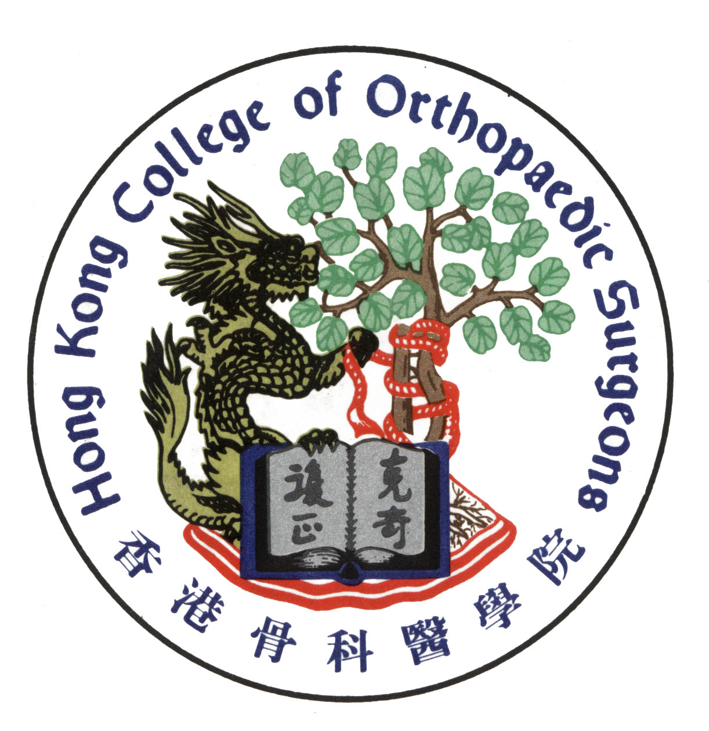

THE HONG KONG COLLEGE OF ORTHOPAEDIC SURGEONS

LECTURES
on
EXAMINATION TECHNIQUE
by
MR. MARK PATERSON
Consultant Paediatric Orthopaedic Surgeon
The Royal London Hospital
London, UK
&
MR. KEVIN SHERMAN
Consultant Orthopaedic Surgeon
Hull and East Yorkshire Hospitals NHS Trust
Hull, UK

Date : 21 September 2004 (Tuesday)
Time : 6:00 – 7:30 p.m.
Venue : Function Room, 2/F
Hong Kong Academy of Medicine Building
99 Wong Chuk Hang Road
Aberdeen, Hong Kong

* For College Fellows Only *
Limited car parking spaces are available on first-come-first-served basis.

